**WITH NOISE AND WITH FILTER**

**Image set:**

|  |
| --- |
| **Image 1:-0.1 % Noise** |

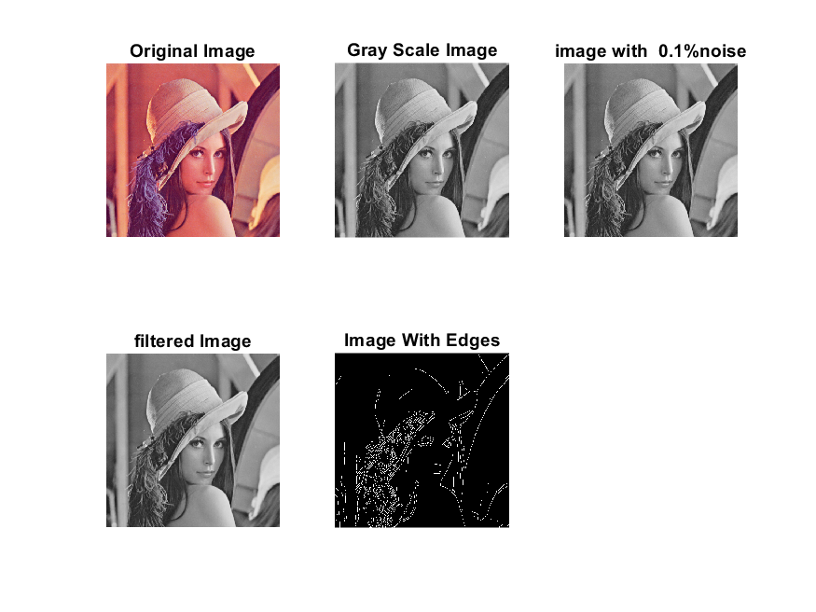

**Image 2:-10 % Noise**

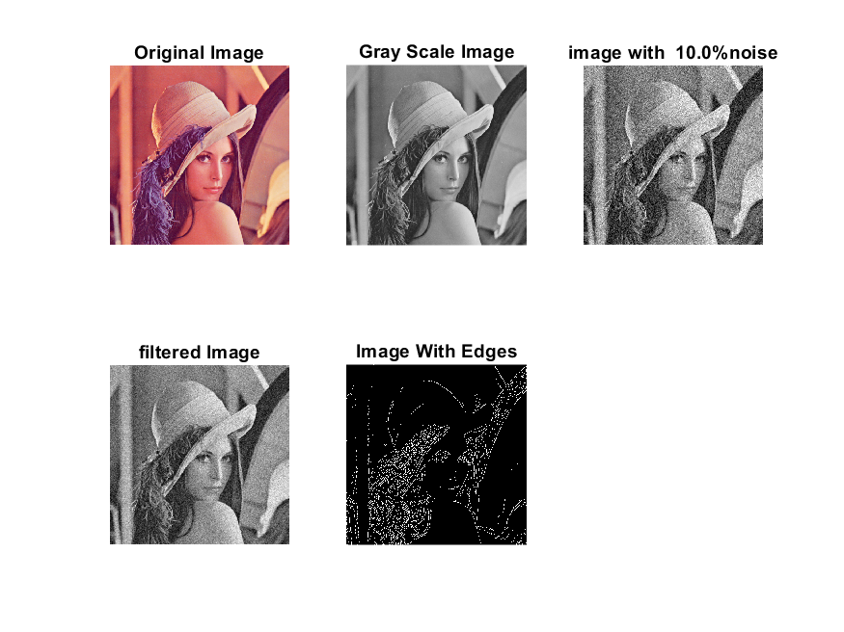

**Image 3:-20 % Noise**

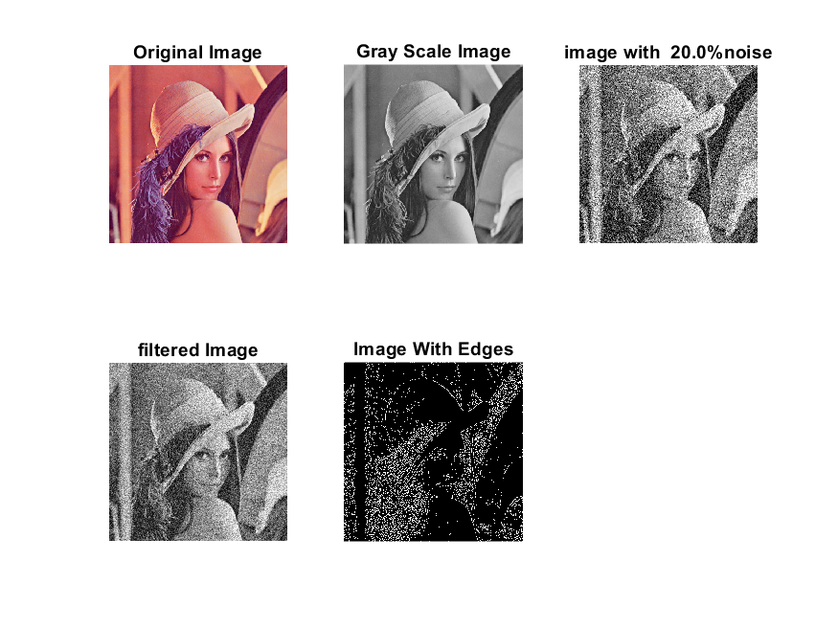

**Image 4:-30 % Noise**

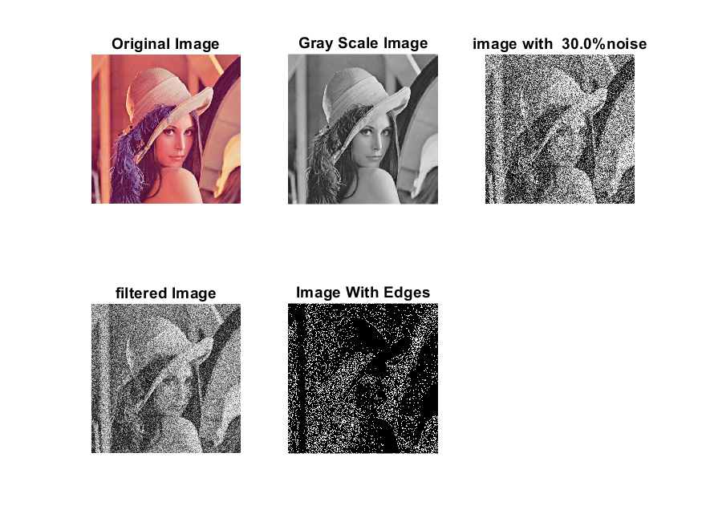

|  |
| --- |
| **Image 5:-40 % Noise** |

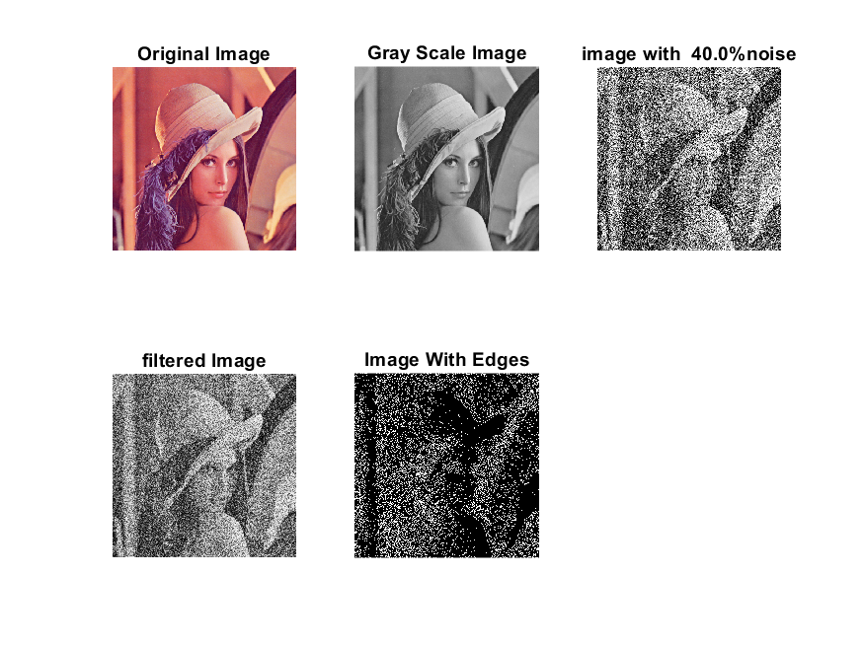

**Image 6:-50 % Noise**

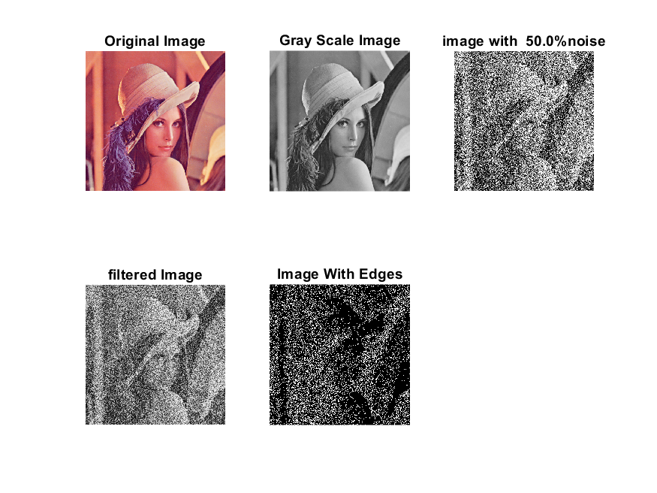

**Image 7:-60 % Noise**

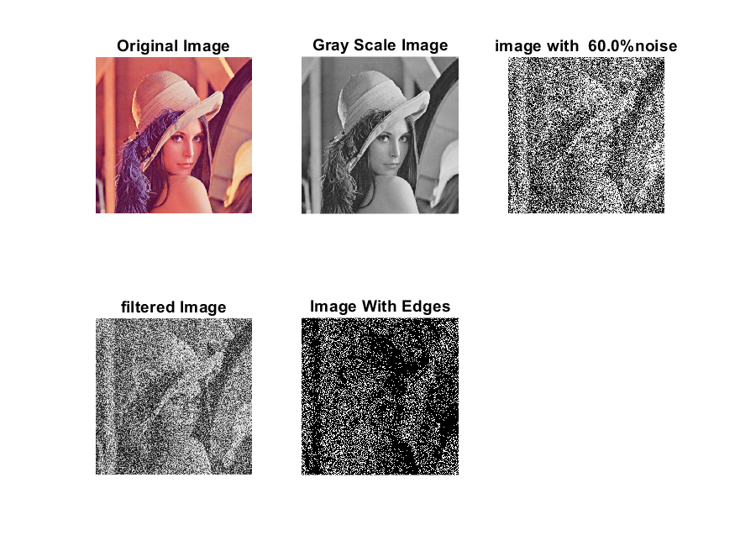

**Image 8:-70 % Noise**

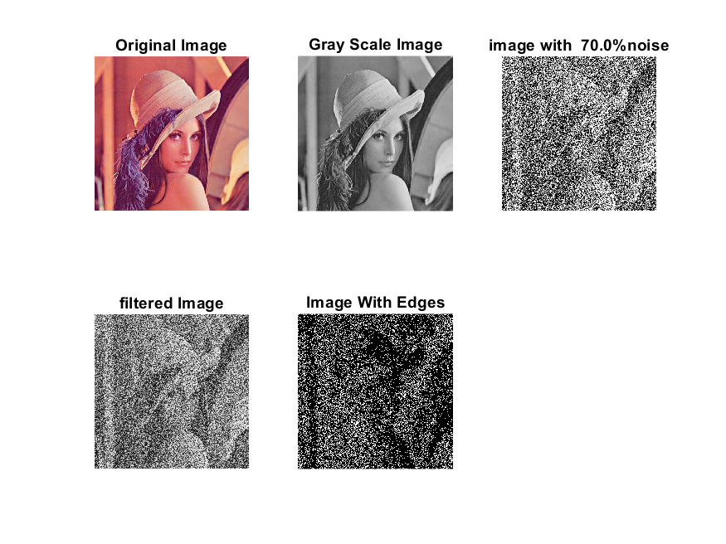

**Image 9:-80 % Noise**

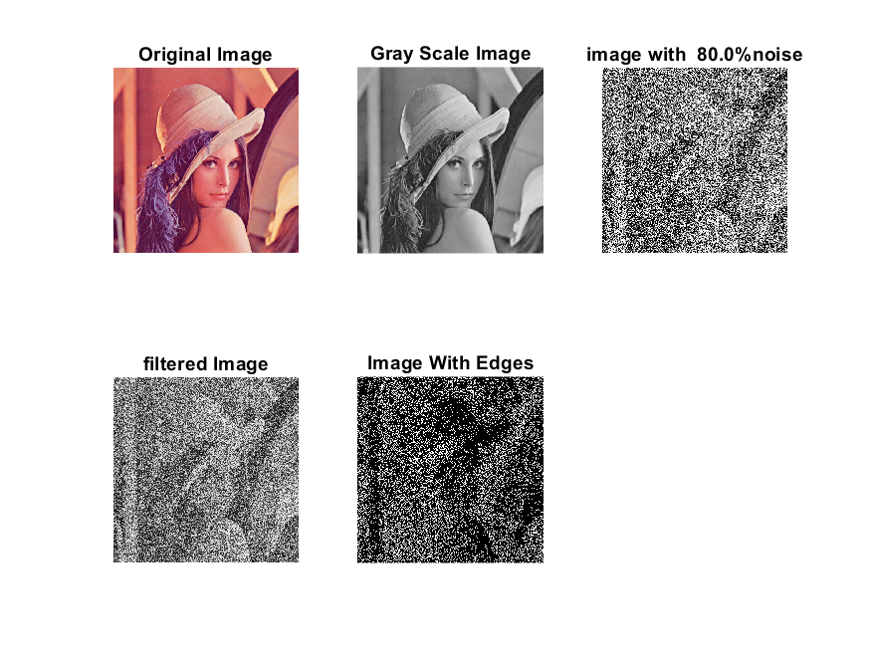

**DATA FILES**

**Image 1:-Noise0.1**

Original image ideal values:

IM1 image entropy:2.518346e-01

IM1 image mean:0.042099

Ground truth image entropy:0.633825

Ground truth image mean:0.159798

entropy between imt and im1 :0.596287

MSE between imt and im1 :0.171600

Average Difference between imt and im1 :0.117699

Maximum Difference between imt and im1 :1.000000

True Positive values:3971.000000

False Positive values: 7065.000000

True Negative values:213189.000000

False Negative values:37919.000000

Accuracy value: 0.828400

F Measure values:0.150059

Peak Signal-to Noise Ration value: 7.654819

Signal-to Noise Ration value: -5.792987

percentage of pixels that were correctly detected (Pco): 0.094796

The percentage of pixels that were not detected (Pnd):0.905204

the percentage of false alarm: (Pfa):0.168656

Euclidean Distance Value :8.577435

**Image 2:-Noise10**

Original image ideal values:

IM1 image entropy:3.251596e-01

IM1 image mean:0.059425

Ground truth image entropy:0.633825

Ground truth image mean:0.159798

entropy between imt and im1 :0.586829

MSE between imt and im1 :0.181610

Average Difference between imt and im1 :0.100372

Maximum Difference between imt and im1 :1.000000

True Positive values:4930.000000

False Positive values: 10648.000000

True Negative values:209606.000000

False Negative values:36960.000000

Accuracy value: 0.818390

F Measure values:0.171574

Peak Signal-to Noise Ration value: 7.408600

Signal-to Noise Ration value: -4.295987

percentage of pixels that were correctly detected (Pco): 0.117689

The percentage of pixels that were not detected (Pnd):0.882311

the percentage of false alarm: (Pfa):0.254190

Euclidean Distance Value :10.844078

**Image 3:-Noise20**

Original image ideal values:

IM1 image entropy:4.809915e-01

IM1 image mean:0.103821

Ground truth image entropy:0.633825

Ground truth image mean:0.159798

entropy between imt and im1 :0.567328

MSE between imt and im1 :0.211296

Average Difference between imt and im1 :0.055977

Maximum Difference between imt and im1 :1.000000

True Positive values:6858.000000

False Positive values: 20358.000000

True Negative values:199896.000000

False Negative values:35032.000000

Accuracy value: 0.788704

F Measure values:0.198478

Peak Signal-to Noise Ration value: 6.751086

Signal-to Noise Ration value: -1.872861

percentage of pixels that were correctly detected (Pco): 0.163714

The percentage of pixels that were not detected (Pnd):0.836286

the percentage of false alarm: (Pfa):0.485987

Euclidean Distance Value :15.426237

**Image 4:-Noise30**

Original image ideal values:

IM1 image entropy:6.229745e-01

IM1 image mean:0.155312

Ground truth image entropy:0.633825

Ground truth image mean:0.159798

entropy between imt and im1 :0.547748

MSE between imt and im1 :0.248505

Average Difference between imt and im1 :0.004486

Maximum Difference between imt and im1 :1.000000

True Positive values:8730.000000

False Positive values: 31984.000000

True Negative values:188270.000000

False Negative values:33160.000000

Accuracy value: 0.751495

F Measure values:0.211370

Peak Signal-to Noise Ration value: 6.046655

Signal-to Noise Ration value: -0.123666

percentage of pixels that were correctly detected (Pco): 0.208403

The percentage of pixels that were not detected (Pnd):0.791597

the percentage of false alarm: (Pfa):0.763524

Euclidean Distance Value :19.887771

**Image 5:-Noise40**

Original image ideal values:

IM1 image entropy:7.013249e-01

IM1 image mean:0.189930

Ground truth image entropy:0.633825

Ground truth image mean:0.159798

entropy between imt and im1 :0.537104

MSE between imt and im1 :0.275555

Average Difference between imt and im1 :-0.030132

Maximum Difference between imt and im1 :1.000000

True Positive values:9722.000000

False Positive values: 40067.000000

True Negative values:180187.000000

False Negative values:32168.000000

Accuracy value: 0.724445

F Measure values:0.212088

Peak Signal-to Noise Ration value: 5.597922

Signal-to Noise Ration value: 0.750230

percentage of pixels that were correctly detected (Pco): 0.195264

The percentage of pixels that were not detected (Pnd):0.646086

the percentage of false alarm: (Pfa):0.804736

Euclidean Distance Value :18.573620

**Image 6:-Noise50**

Original image ideal values:

IM1 image entropy:7.462011e-01

IM1 image mean:0.212482

Ground truth image entropy:0.633825

Ground truth image mean:0.159798

entropy between imt and im1 :0.527568

MSE between imt and im1 :0.291439

Average Difference between imt and im1 :-0.052685

Maximum Difference between imt and im1 :1.000000

True Positive values:10596.000000

False Positive values: 45105.000000

True Negative values:175149.000000

False Negative values:31294.000000

Accuracy value: 0.708561

F Measure values:0.217151

Peak Signal-to Noise Ration value: 5.354522

Signal-to Noise Ration value: 1.237526

percentage of pixels that were correctly detected (Pco): 0.190230

The percentage of pixels that were not detected (Pnd):0.561821

the percentage of false alarm: (Pfa):0.809770

Euclidean Distance Value :18.069709

**Image 7:-Noise60**

Original image ideal values:

IM1 image entropy:7.722274e-01

IM1 image mean:0.226707

Ground truth image entropy:0.633825

Ground truth image mean:0.159798

entropy between imt and im1 :0.521789

MSE between imt and im1 :0.301674

Average Difference between imt and im1 :-0.066910

Maximum Difference between imt and im1 :1.000000

True Positive values:11119.000000

False Positive values: 48311.000000

True Negative values:171943.000000

False Negative values:30771.000000

Accuracy value: 0.698326

F Measure values:0.219483

Peak Signal-to Noise Ration value: 5.204623

Signal-to Noise Ration value: 1.518954

percentage of pixels that were correctly detected (Pco): 0.187094

The percentage of pixels that were not detected (Pnd):0.517769

the percentage of false alarm: (Pfa):0.812906

Euclidean Distance Value :17.755432

**Image 8:-Noise70**

Original image ideal values:

IM1 image entropy:7.937402e-01

IM1 image mean:0.239220

Ground truth image entropy:0.633825

Ground truth image mean:0.159798

entropy between imt and im1 :0.516772

MSE between imt and im1 :0.310753

Average Difference between imt and im1 :-0.079422

Maximum Difference between imt and im1 :1.000000

True Positive values:11569.000000

False Positive values: 51141.000000

True Negative values:169113.000000

False Negative values:30321.000000

Accuracy value: 0.689247

F Measure values:0.221205

Peak Signal-to Noise Ration value: 5.075849

Signal-to Noise Ration value: 1.752264

percentage of pixels that were correctly detected (Pco): 0.184484

The percentage of pixels that were not detected (Pnd):0.483511

the percentage of false alarm: (Pfa):0.815516

Euclidean Distance Value :17.494617

**Image 9:-Noise80**

Original image ideal values:

IM1 image entropy:8.069264e-01

IM1 image mean:0.247272

Ground truth image entropy:0.633825

Ground truth image mean:0.159798

entropy between imt and im1 :0.514899

MSE between imt and im1 :0.317532

Average Difference between imt and im1 :-0.087475

Maximum Difference between imt and im1 :1.000000

True Positive values:11736.000000

False Positive values: 53085.000000

True Negative values:167169.000000

False Negative values:30154.000000

Accuracy value: 0.682468

F Measure values:0.219959

Peak Signal-to Noise Ration value: 4.982131

Signal-to Noise Ration value: 1.896054

percentage of pixels that were correctly detected (Pco): 0.181052

The percentage of pixels that were not detected (Pnd):0.465189

the percentage of false alarm: (Pfa):0.818948

Euclidean Distance Value :17.151817